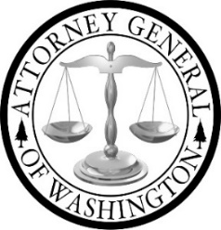

Tribal Advisory Committee (TAC)
Cultural and Resource Protection Subcommittee

Cultural and Resource Protection Subcommittee
Meeting Agenda: May 6, 2025, 4:00 pm to 5:00 pm

Join Zoom Meeting: https://atg-wa.zoom.us/j/82610425451?pwd=SwyRPawUeXdaHjxlqi928aCWlCQL2h.1

1. | Open Meeting  Introductions  Present:  Staff:
2. | Project Extension Update | Update
3. | Emmett Till Project Update | Update
4. | TAC Report Update | Update
5. | WSHS Invitation | Information
6. | Recommendation Edits Review | Discussion
 | Adjourn

