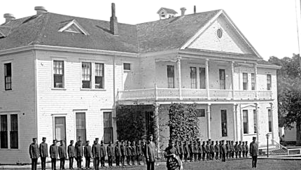

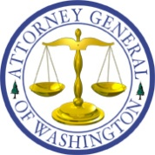
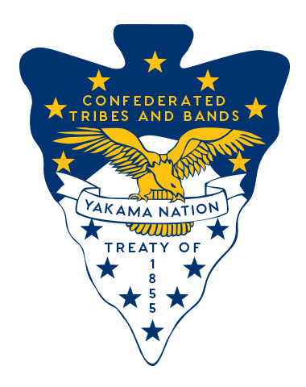
Hosted by
Confederated Tribes and Bands of the Yakama Nation
Washington State Attorney General’s Office
Dates: | March 17 & 18
Time: | 8:00 AM - 5:00 PM
Location: | Toppenish Community Center; Toppenish, Washington
Purpose
Yakama Nation and the Washington State Attorney General invite boarding school survivors, tribal members, and descendants to participate in a Truth & Healing Listening Session. This gathering provides a respectful space to share stories, honor lived experiences, and support community healing.
What to Expect
- Opening prayer & cultural protocol
- Survivor testimony (voluntary)
- Facilitated listening circles
- Wellness & emotional support resources
- Light refreshments & Meals provided
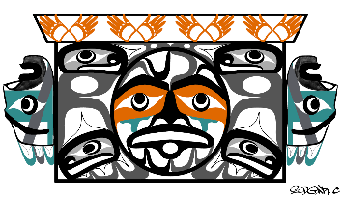
REGISTER

CONTACT INFORMATION
For questions or to share testimony privately, contact:
Arlen Washines at yn_boardingschool@yakama.com

