

Tribal Advisory Committee (TAC)
Meeting Agenda 07/07/2026
1:00 pm - 3:00 pm
Join Zoom Meeting
https://atg-wa.zoom.us/j/83337590218?pwd=XORCUd6mszQjIw3tuCy3JsjgbIj8z1.1
1. | Call to Order: Opening of Meeting  - Hold space
2. | Approval of Minutes  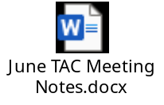 | O Action
3. | Budget/Proviso Update: No Updates | O Action
4. | Work Planning  - Reach back out to Colville, get meeting on the books  - Connect with Spokane Tribe, initial plan to have listening session at same time as Orange Shirt Day | O Action
5. | Discussion:  - TAC Report  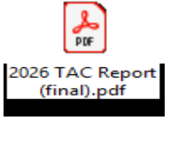  - Quinault Listening Session | O Action
6. | Adjourn | O Action

