

Tribal Advisory Committee (TAC)

Meeting Agenda 04/14/2026
1:00 pm - 3:00 pm
Join Zoom Meeting
https://atg-wa.zoom.us/j/83337590218?pwd=XORCUd6mszQjIw3tuCy3JsjgbIj8z1.1
1. | Call to Order: Opening of Meeting  - Hold space  - Open Meeting
2. | Approval of Minutes  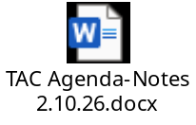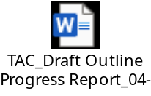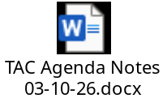 | O Action
3. | Budget/Proviso Update: Ellen | O Action
4. | Work Planning  - Update on Yakama listening session | O Action
5. | TAC Report  - Deadline: June 1st | O Action
6. | Discussion:  - Spokane Tribe of Indians – meeting scheduled 03/30/26 – update TAC  - Colville Tribe – meeting scheduled 04/09/26 – update TAC  - Quinault - on hold for now  - Suquamish – no outreach done yet  - Puyallup – no outreach done yet | O Action
7. | Adjourn | O Action

