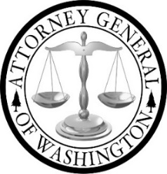

Tribal Advisory Committee (TAC)

Meeting Agenda 9/9/2025
1:00 pm - 3:00 pm
Join Zoom Meeting
https://atg-wa.zoom.us/j/84813861400?pwd=i5rAgi1oPamfVoSFvUpwyN8l3vXPDJ.1
1. | Call to Order: Opening of Meeting  - Hold space  - Open Meeting
2. | Approval of Minutes | O Action
3. | November TAC Meeting Reschedule | O Action
4. | AGO Staff- Roles and Contact Information | O Discussion  O Information
5. | NCAI Breakout Session | O Discussion  O Action
6. | Proviso Extension | O Information
7. | Class 1 Volunteer Stipends | O Information
8. | Orange Shirt Day | O Action
 | Break
9. | LS Updates | O Information
10. | LPC Draft Presentation, Resources, and Planning Docs | O Information  O Feedback
11. | Work Planning  Report dates, LS, research, report outline/writing- TAC inclusion and participation, TAC meeting w/ AG Nick Brown | O Action
12. | Adjourn

