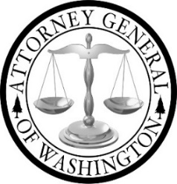

Boarding School Tribal Advisory Committee

Meeting Agenda 6/10/2025
Join Zoom Meeting
https://atg-wa.zoom.us/j/84813861400?pwd=i5rAgi1oPamfVoSFvUpwyN8l3vXPDJ.1

1. | Call to Order: Opening of Meeting  - Hold space  - Open Meeting
2. | Asa Washines  - Purpose and intent of report  - Who the work is for vs intent of the report  - These efforts lay the groundwork for future work on this project and other issues affecting Washington tribes | Discussion
3. | Thanking the TAC  - The foundations being built are vital to doing this work in a good way  - Changes to internal processes will allow for earlier meaningful consultation and collaboration with the TAC and, ultimately, tribal leadership and community  - Bureaucracy is large and slow to change, meaningful change has occurred because of their guidance | Discussion
4. | Report Comparison Feedback  AGO approved draft  TAC draft  Version selection  Additional edits | Discussion
5. | Press Release and Talking to the Press | Discussion
6. | Adjourn

