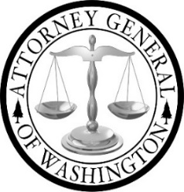

Boarding School Tribal Advisory Committee

Meeting Agenda 7/08/2025

Join Zoom Meeting:
https://atg-wa.zoom.us/j/84813861400?pwd=i5rAgi1oPamfVoSFvUpwyN8l3vXPDJ.1

1. | Call to Order: Opening of Meeting  - Hold space  - Open Meeting
2. | Takeaways from Phase One | O Discussion and feedback
3. | Report and Press Release | O Discussion and Feedback
4. | AGO Updates | O Information and Discussion
5. | Break
6. | TAC Work Planning Preparation | O Discussion
9. | Adjourn

